|  |  |
| --- | --- |
| File:COMSATS new logo.jpg - Wikimedia Commons  ***PROGRAMMING FUNDAMENTALS***  CLASS & Assignment 01 | **submitted by:**  **Shahzaneer Ahmed**  **registration number:**  **SP21-BCS-087**  **submitted to:**  **MR. RIZWAN RASHID**  **date of submission:**  **October 29,2021** |

# Class Assignment 01

Question 1

Source Code

// |----------------------------------------------------------|

// |------------------Shahzaneer Ahmed------------------------|

// |-------------------SP21-BCS-087---------------------------|

// |----------------------------------------------------------|

//Question – 1: This question focuses on the types of errors

// a. Write JAVA statements that can produce Syntax Errors. Give three different examples

// and write the names of errors

// b. Write JAVA statements that can produce Logical Errors. Give three different examples

// and briefly explain the reason (1-2 lines)

// c. Write JAVA statements that can produce Run Time Errors. Give three different examples

// and briefly explain the reason (1-2 lines)

// d. The following program has syntax errors. Write clearly type of error and its correction

// (in tabular form). After you have corrected the syntax errors, show the output of this

// program.

// count = 1;

// sum = count + PRIME;

// x := 25.67;

// newNum = count * ONE + 2;

// sum + count = sum;

// x = x + sum * COUNT;

// System.out.println(" count = " + count + ", sum = "

// + sum + ", PRIME = " + Prime);

import java.util.Scanner;

public class Question1 {

public static void main(String[] args) {

int count = 1; // count is not declared!

int PRIME = 1;

int sum = count + PRIME; //sum was not declared and prime was not initialized

double x = 25.67; //invalid syntax for initializing and declaring is absent

int ONE = 1;

int newNum = count * ONE + 2; //newNum and ONE were not declared!

sum = sum+count; // we have to assign a value to the left and the components to the right.

x = x + sum * count; //invalid identifier name

System.out.println(" count = " + count + ", sum = "

+ sum + ", PRIME = " + PRIME); //invalid identifier name

}

}

class A{

// solution to a.

// a.1

// a = 10; // identifier expected

// it can be resolved by putting the keyword of identifier which is int in this case

// a.2

// int ahmed(int x){

// System.out.println("this is ahmed");

// } //missing return statement

// the function is returning int and we have returned nothing so it is showing us an error

// a.3

//public static void main(String[] args) {

// System.out.println("Shahzaneer Ahmed!") //terminator missing error , semi colon was expected

//}

}

class B{

// solution to b

// b.1

// int a=10 ,b= 3;

// int sum = a*b; // a logical error as we were supposed to add them but we just multiplied them.

// b.2

// int a = 10 , b = 3 , c = 90;

// int avg = (a+b+c)/100; //we were supposed to get average of three numbers and instead of dividing it by 3 we

// divided it by 100 which is a logical mistake

// b.3

// int a = 10;

// int b = 100;

// int remainder = b/a; // instead of taking modulo % we have divided which will give us quotient not the remainder

// and this is also a logical mistake.

}

class C {

// solution to c

// c.1

static int a = 1;

// int b = a/0; // division by zero is not possible the program will crash ultimately therefore it runtime error

// as it shows upo during the execution of the program.

// c.2

//public static void main(String[] args) {

// System.out.printf("Im shahzaneer Ahmed! %s %d ", a); //missing argument error , it is not a logical not a syntax

// error but during the execution of program the program was collapsed

// c.3

// Scanner obj = new Scanner(System.in);

// int = obj.nextInt(); // instead to entering an integer value if I typed a String value the prgram will crash in the

// meantime , not handling certain input values also results in runtime errors

}

Screenshots

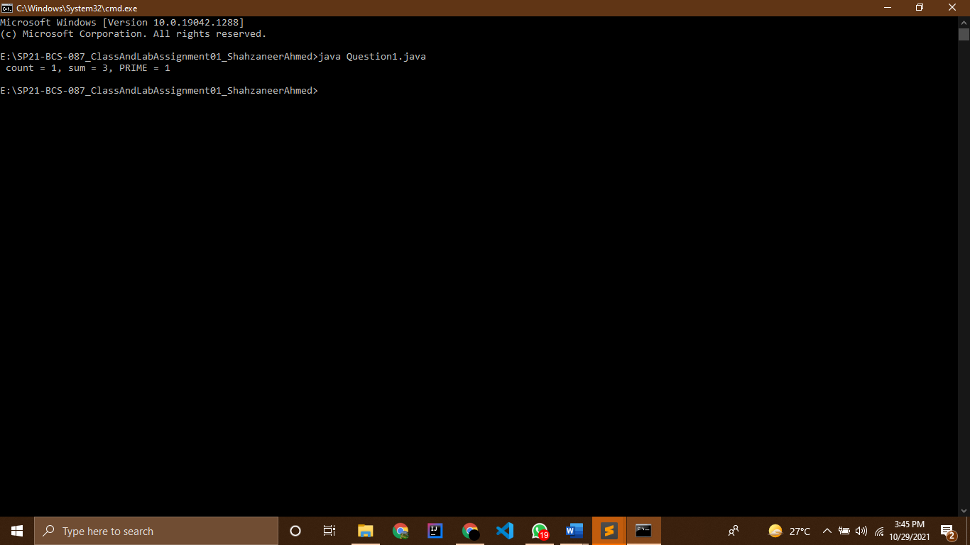

Question 2

Source Code

// |----------------------------------------------------------|

// |------------------Shahzaneer Ahmed------------------------|

// |-------------------SP21-BCS-087---------------------------|

// |----------------------------------------------------------|

//Question – 2: This question focuses on the basic elements of JAVA language (comments,

// Special Symbols, Reserve Words and Identifiers)

// Consider following JAVA Code

///*This program will calculate product of three numbers */

//public class Product{

// public static void main(String[] args){

// int num1 = 10; // first number

// int num2 = 20; // second number

// int num3 = 1;// third number

// int result; //product of numbers

// result = num1 * num2 * num3;

// System.out.println("Product of numbers: "+result);

// }

//}

// You are required to identify following (Show your answer as tabular form)

//- comments (Single Line, Multiline),

// - Special symbols (three)

// - Reserve words (three)

// - Identifier (predefined and defined by user) (three each)

// - Standard Input Stream Object

// - Standard Output Stream Object

public class Question2 {

public static void main(String[] args) {

int num1 = 10; // first number

int num2 = 20; // second number

int num3 = 1;// third number

int result; //product of numbers

result = num1 * num2 * num3;

System.out.println("Product of numbers: "+result);

System.out.println("The Single line comments are written after // and multiline comments are written after /*..... */");

System.out.println("In this case there are single line comments after the initialization of num1,num2,num3 " +

"and declaration of result ");

System.out.println("Special Symbols Include // , * , ; , ");

System.out.println("Reserve words : public , static , void , main , int ,String ");

System.out.println("For Standard input Stream we use Scanner class to get input from the keyboard but in this" +

" case we have no Standard input Stream rather we have hardcoded the values");

System.out.println("System.out.println() is the function which is standard output Stream ");

}

} }

Screenshots

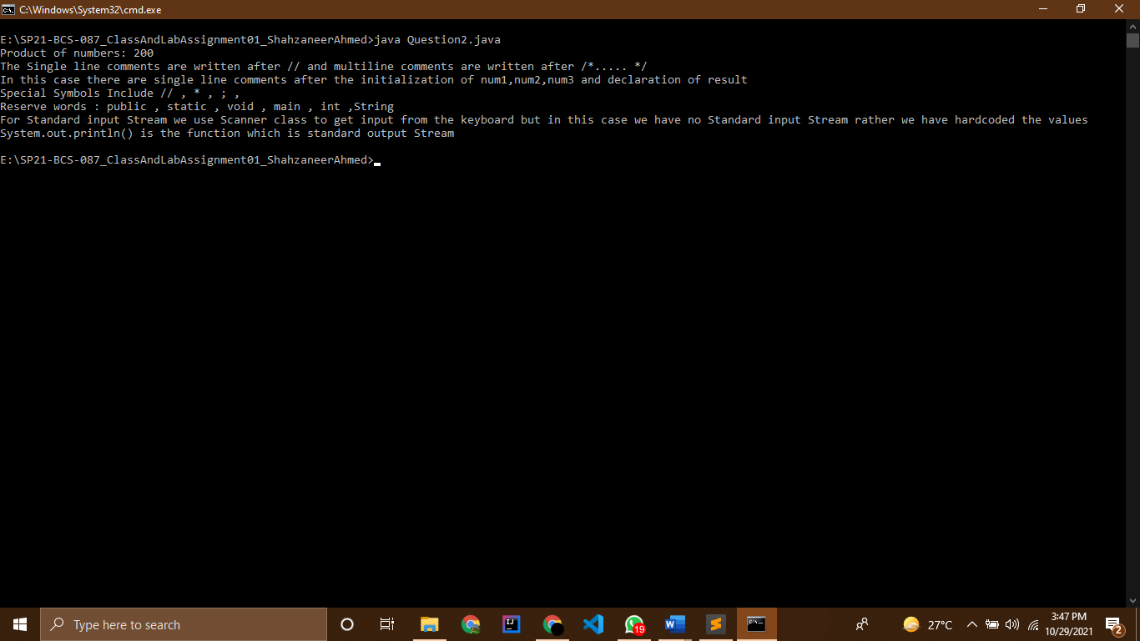

Question 3

Source Code

// |----------------------------------------------------------|

// |------------------Shahzaneer Ahmed------------------------|

// |-------------------SP21-BCS-087---------------------------|

// |----------------------------------------------------------|

//Question – 3: This question focuses on the basic elements of JAVA language (Primitive Data

// Types, Expressions and Assignments, Arithmetic Operators, Order of Precedence, Augmented

// Assignment Operators, Type Conversion)

// a. Write Java statements that accomplish the following.

// o Declare int variables x and y.

// o Initialize an int variable x to 10 and a char variable ch to ' B '.

// o Update the value of an int variable x by adding 5 to it.

// o Declare and initialize a double variable payRate to 12.50.

// o Copy the value of an int variable firstNum into an int variable tempNum.

// o Swap the contents of the int variables x and y. (Declare additional variables, if

// necessary.)

// o Suppose x and y are double variables. Output the contents of x , y , and the

// expression x +12/ y – 18.

// o Declare a char variable grade and set the value of grade to 'A'.

// o Declare int variables to store four integers.

// o Copy the value of a double variable z to the nearest integer into an int variable

// x.

// b. Suppose a, b and c are int variables and a = 5, b = 6, d = 2. What value is assigned to

// each variable after each statement executes? If a variable is undefined at a particular

// statement, report UND (undefined)

// Statements a b c d

// a = (b++) + 3 * ++d;

// c = 2 * d + (++b) + a;

// b = 2 * (++c) - (a++);

// d = d++ + d + b++ + b;

// c. Suppose a, b, and sum are int variables and c is a double variable. What value is

// assigned to each variable after each statement executes? Suppose a = 3 , b = 5 ,

// and c = 14.1

// Statements a b c sum

// sum = a + b + ( int) c;

// c /= a;

// b += (int) c - a;

// a *= 2 * b + (int) c

public class Question3 {

public static void main(String[] args) {

// solution to a.

// int x,y;

// x = 10;

// char ch = 'B';

// x = x+5;

// double payRate = 12.50;

// int firstNum = 4;

// int tempNum;

// tempNum = firstNum;

//

// x = 12;

// y = 10;

// int tempVar = 0;

// tempVar = y;

// x = y;

// y = x;

// double x = 44.55, y = 55.45;

// System.out.println("x :"+x);

// System.out.println("y :"+y);

// System.out.println((x+12/y-18)); //26.766411181244358

//

// char grade = 'A';

// int variable = 3333;

//

// double z = 66.77;

// x = (int) z; //66.0

// System.out.println(x);

// solution to b.

// int a = 5, b = 6, d=2;

// a = (b++) + 3 * ++c;

// System.out.printf("%d %d %d %d", a,b,c, d); //15 7 UN 3

// int c = 2 * d + (++b) + a;

// System.out.printf("%d %d %d %d", a,b,c ,d); //5 7 16 2

// b = 2 * (++c) - (a++);

// System.out.printf("%d %d %d %d", a,b,c ,d); // 6 29 17 2

// d = d++ + d + b++ + b;

// System.out.printf("%d %d %d %d", a,b,c ,d); //5 8 16 20

// solution to c.

int a = 3 , b = 5 ;

double c = 14.1;

int sum = a+b+ (int)c;

//System.out.printf("%d %d %f %d", a,b,c ,sum); // 3 5 14.100000 22

c /= a;

//System.out.printf("%d %d %f %d", a,b,c ,sum); //3 5 14.100000 223 5 4.700000 22

b += (int) c - a;

// System.out.printf("%d %d %f %d", a,b,c ,sum); //3 6 4.700000 22

a *= 2 * b + (int) c;

System.out.printf("%d %d %f %d", a,b,c ,sum); //48 6 4.700000 22

}

}

Screenshots

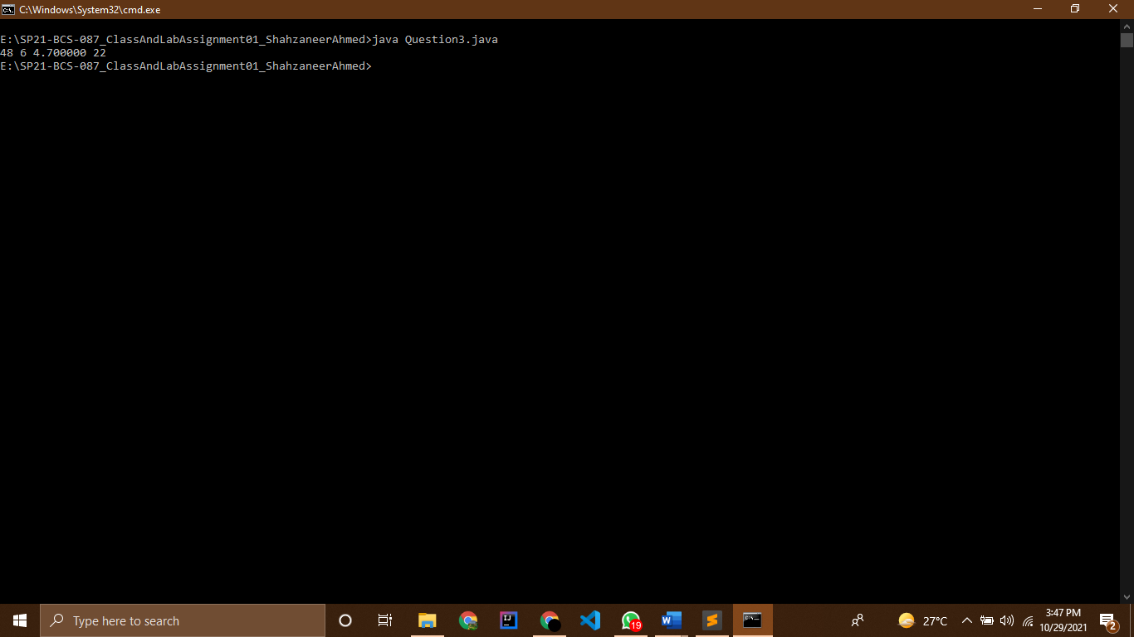

Tabular Representation:

b)

|  |  |  |  |  |
| --- | --- | --- | --- | --- |
| **Statements** | **a** | **b** | **c** | **d** |
| a = (b++) + 3 * ++d; | 15 | 7 | UND | 3 |
| c = 2 * d + (++b) + a; | 15 | 8 | 29 | 3 |
| b = 2 * (++c) - (a++); | 16 | 45 | 30 | 3 |
| d = d++ + d + b++ + b; | 16 | 46 | 30 | 98 |

c)

|  |  |  |  |  |
| --- | --- | --- | --- | --- |
| **Statements** | **a** | **b** | **c** | **sum** |
| sum = a + b + ( int) c; | 3 | 5 | 14.1 | 22 |
| c /= a; | 3 | 5 | 4.7 | 22 |
| b += (int) c - a; | 3 | 6 | 4.7 | 22 |
| a *= 2 * b + (int) c; | 48 | 6 | 4.7 | 22 |

Question 4

Source Code

// |----------------------------------------------------------|

// |------------------Shahzaneer Ahmed------------------------|

// |-------------------SP21-BCS-087---------------------------|

// |----------------------------------------------------------|

//Question – 4: This question focuses on the Selection Structure in JAVA Language

// a. Suppose that you have the following declaration:

// int j = 0;

// The output of the statement:

// if ((8 > 4) || (j++ == 7))

// System.out.println("j = " + j);

// is:

// j = 0

// while the output of the statement:

// if ((8 > 4) | (j++ == 7))

// System.out.println("j = " + j);

// is:

// j = 1

// Explain why?

// b. Suppose that x, y, and z are int variables and x = 10 , y = 15 , and z = 20.

// Determine whether the following expressions evaluates to true or false.

// Expression Result

// !(x > 1 0)

// x <= 5 || y < 15

// (x != 5 ) && (y != z)

// x >= z || (x + y >= z)

// (x <= y – 2) && (y >= z) || (z – 2 != 20)

// c. Rewrite the following expressions using the conditional operator

// Expressions Conditional Operator

// if (x >= y)

// z = x - y;

// else

// z = y - x;

// if (hours >= 40.0)

// wages = 40 * 7.50 + 1.5

// * 7.5 * (hours - 40);

// else

// wages = hours * 7.50;

// if (score >= 60)

// str = "Pass";

// else

// str = "Fail"

public class Question4 {

public static void main(String[] args) {

// solution to a.

int j = 0;

if ((8 > 4) || (j++ == 7) )

System.out.println("j = " + j);

// Reason :

// here j = 0 , and then there is an or operator between two statements we know that or operator returns true

// if any one statement is true , the program will look for the first statement to be true if it is true then it

// will overlook the second statement without evaluating it. therefore the value of j remains zero!

if ((8 > 4) | (j++ == 7))

System.out.println("j = " + j);

// Reason :

// here bitwise or is used for which the statements are firstly executed and then converted to binary forms .

// After this or operation is performed . Therefore j transformed in j = 1.

// solution to b.

int x = 10 , y = 15;

// z = 20;

// System.out.println((!(x > 10))); //True

// System.out.println(x <= 5 || y < 15); //False

// System.out.println((x != 5 ) && (y != z)); //True

// System.out.println(x >= z || (x + y >= z)); //True

// boolean bool1 = (x <= 13);

// boolean bool2 = (y >= z);

// boolean bool3 = (18!= 20);

// System.out.println( bool1 && bool2 || bool3 ); //True

// solution to c.

// c.1

int z ;

z = (x > y || x==y) ? x - y: y - x;

// c.2

double wages,hours=12;

wages = (hours >= 40.0) ? 40 * 7.50 + 1.5 * 7.5 * (hours - 40) : hours *7.50;

// c.3

String str ;

int score = 80;

str = (score >= 60) ? "pass":"fail";

}

}

Screenshots

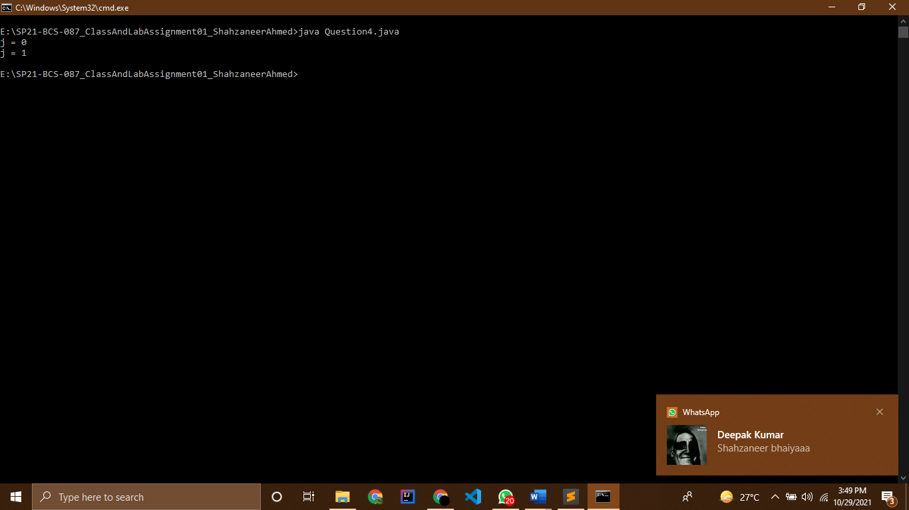

Question 5

Source Code

// |----------------------------------------------------------|

// |------------------Shahzaneer Ahmed------------------------|

// |-------------------SP21-BCS-087---------------------------|

// |----------------------------------------------------------|

//Question – 5:

// The two roots of a quadratic equation ax2

// + bx + c = 0 can be obtained using the following

// formula:

// b

// 2

// - 4ac is called the discriminant of the quadratic equation. If it is positive, the equation has two

// real roots. If it is zero, the equation has one root. If it is negative, the equation has no real roots.

// Write a program that prompts the user to enter values for a, b, and c and displays the result

// based on the discriminant. If the discriminant is positive, display two roots. If the discriminant is

// 0, display one root. Otherwise, display “The equation has no real roots”.

// Note that you can use Math.pow(x, 0.5) to compute . Here are some sample runs.

import java.util.Scanner;

public class Question5 {

public static void main(String[] args) {

Scanner obj = new Scanner(System.in);

System.out.println("for a quadratic equation ax^2 + bx + x + c = 0 ");

System.out.println("Enter the value for a :");

double a = obj.nextDouble();

System.out.println("Enter the value for b :");

double b = obj.nextDouble();

System.out.println("Enter the value for c :");

double c = obj.nextDouble();

double disc = (b*b) - (4*a*c);

double x = Math.pow(disc,0.5);

double root_1 = ((-b + x)/(2*a));

double root_2 = ((-b - x)/(2*a));

double root = (-b)/(2*a);

int discriminant = (int) disc;

// System.out.printf(" %f %f %f %f %f" , disc,x,root_1,root_2,root); chal rha hai k nhi chal rha hai statement!

if ( discriminant==0){

System.out.println("The equation has One real root");

System.out.println("The root is :"+root);

}

else if ( discriminant > 0){

System.out.println("The equation has two real roots");

System.out.printf("The roots are %f and %f" , root_1 , root_2);

}

else if (discriminant < 0){

System.out.println("The equation has No real root");

}

}

}

Screenshots

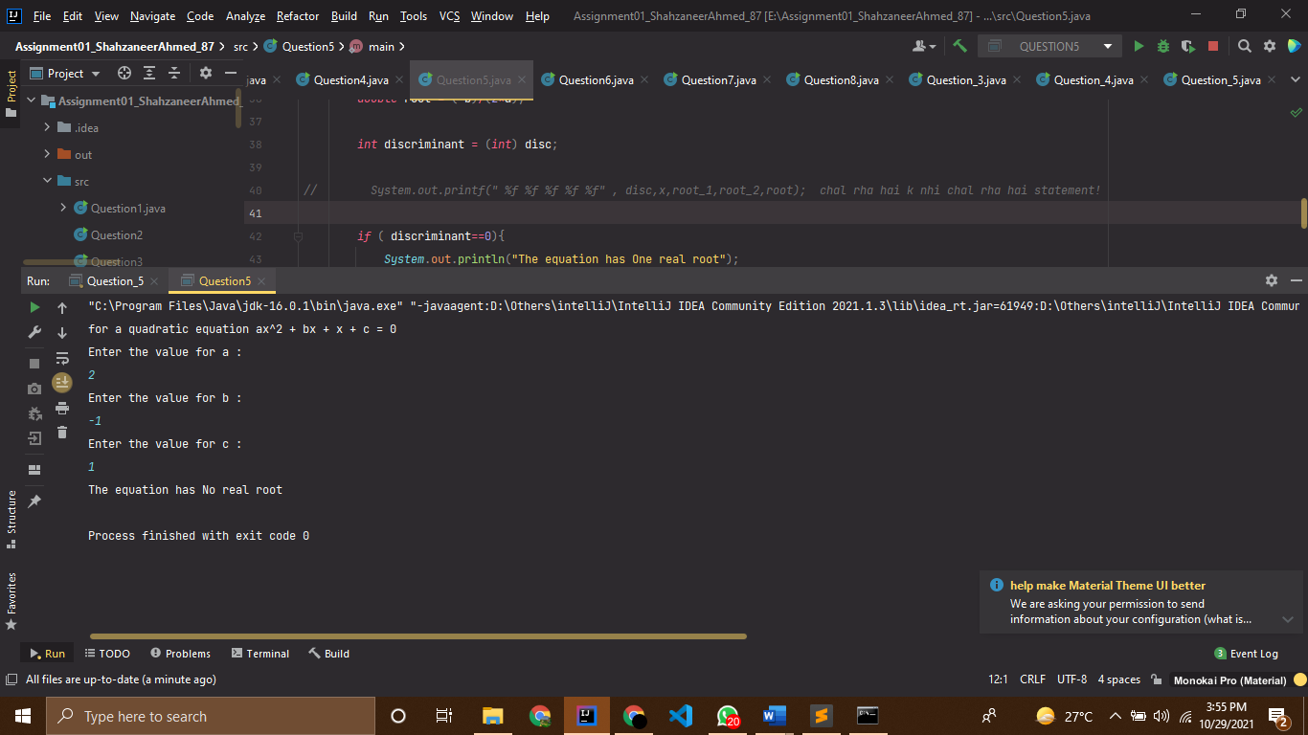

Question 6

Source Code

**// |----------------------------------------------------------|**

**// |------------------Shahzaneer Ahmed------------------------|**

**// |-------------------SP21-BCS-087---------------------------|**

**// |----------------------------------------------------------|**

**//Question – 6:**

**// Write a program that randomly generates an integer between 1 and 12 and displays the English**

**// month name January, February, …, December for the number 1, 2, …, 12, accordingly.**

**import java.util.*;**

**public class Question6 {**

**public static void main(String[] args) {**

**// random is a static method therefore we have make its object, it ranges between 0.0 to 0.99**

**int rand = (int ) (Math.random() * 12) + 1; // it will return numbers between 1 to 12**

**// System.out.println(rand);**

**switch (rand){**

**case 1:**

**System.out.println("January!");**

**break;**

**case 2:**

**System.out.println("February!");**

**break;**

**case 3:**

**System.out.println("March!");**

**break;**

**case 4:**

**System.out.println("April!");**

**break;**

**case 5:**

**System.out.println("May!");**

**break;**

**case 6:**

**System.out.println("June!");**

**break;**

**case 7:**

**System.out.println("July!");**

**break;**

**case 8:**

**System.out.println("August!");**

**break;**

**case 9:**

**System.out.println("September!");**

**break;**

**case 10:**

**System.out.println("October!");**

**break;**

**case 11:**

**System.out.println("November!");**

**break;**

**case 12:**

**System.out.println("December!");**

**break;**

**}**

**}**

**}**

Screenshots

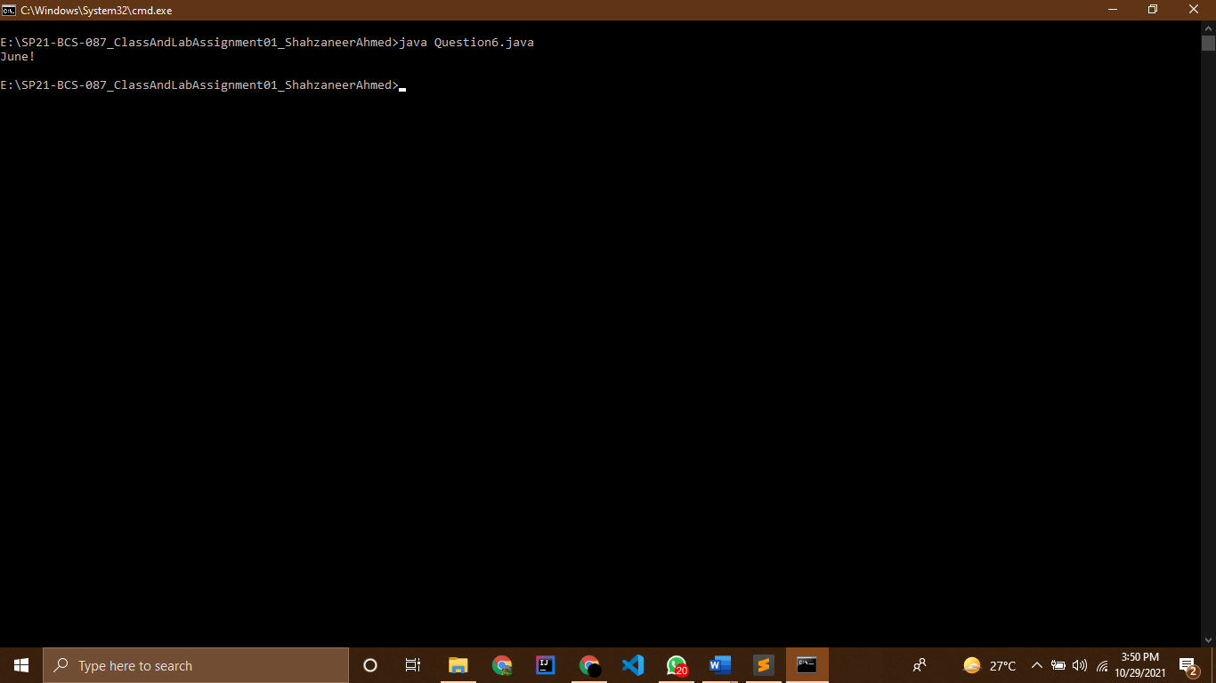

Question 7

Source Code

// |----------------------------------------------------------|

// |------------------Shahzaneer Ahmed------------------------|

// |-------------------SP21-BCS-087---------------------------|

// |----------------------------------------------------------|

//Question – 7:

// Write a program that prompts the user to enter three integers and display the integers in nondecreasing orde

import java.util.Scanner;

public class Question7 {

public static void main(String[] args) {

Scanner obj = new Scanner(System.in);

System.out.println("Enter integer 01 ");

int integer1 = obj.nextInt();

System.out.println("Enter integer 02 ");

int integer2 = obj.nextInt();

System.out.println("Enter integer 03 ");

int integer3 = obj.nextInt();

int big=0 , small=0 , mid=0;

//for big value

if (integer1>integer2 && integer1>integer3) big = integer1;

if (integer2>integer1 && integer2>integer3) big = integer2;

if (integer3>integer1 && integer3>integer2) big = integer3;

// for mid value

if (integer1>integer2 && integer1<integer3) mid = integer1;

if (integer1>integer3 && integer1<integer2) mid = integer1;

if (integer2>integer1 && integer2<integer3) mid = integer2;

if (integer2<integer1 && integer2>integer3) mid = integer2;

if (integer3>integer1 && integer3<integer2) mid = integer3;

if (integer3<integer1 && integer3>integer2) mid = integer3;

// for smaller value

if (integer1<integer2 && integer1<integer3) small = integer1;

if (integer2<integer1 && integer2<integer3) small = integer2;

if (integer3<integer1 && integer3<integer2) small = integer3;

System.out.printf("The values in non decreasing orders are %d %d %d:" , big, mid , small);

}

}

Screenshots

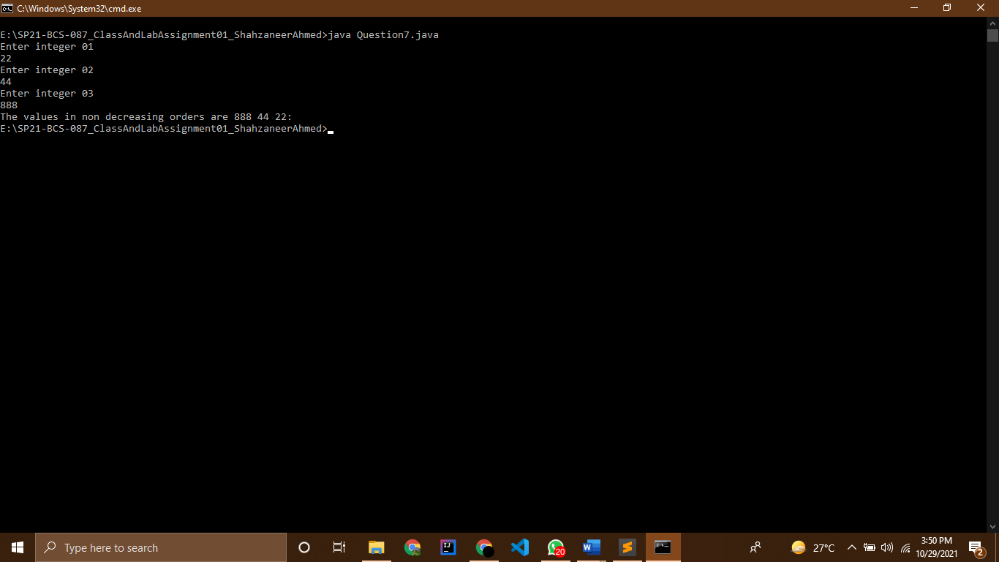

Question 8

Source Code

// |----------------------------------------------------------|

// |------------------Shahzaneer Ahmed------------------------|

// |-------------------SP21-BCS-087---------------------------|

// |----------------------------------------------------------|

// Question – 8:

// Write a program that prompts the user to enter an integer for today’s day of the week (Sunday

// is 0, Monday is 1, …, and Saturday is 6). Also prompt the user to enter the number of days after

// today for a future day and display the future day of the week.

import java.util.Scanner;

public class Question8 {

public static void main(String[] args) {

Scanner obj = new Scanner(System.in);

System.out.println("Enter 0 for Sunday ");

System.out.println("Enter 1 for Monday ");

System.out.println("Enter 2 for Tuesday ");

System.out.println("Enter 3 for Wednesday ");

System.out.println("Enter 4 for Thursday ");

System.out.println("Enter 5 for Friday ");

System.out.println("Enter 6 for Saturday ");

int todayDate = obj.nextInt();

System.out.println("Enter no of days after today :");

int elapsedDays = obj.nextInt();

int future_day = (todayDate+elapsedDays)%7; // today day + day to be elapsed ko add kr k 7 per divide krna

// hai jo bhi remainder ayega jo hamaray future day ko show karega !

String todayDay = "";

switch (todayDate) {

case 0:

todayDay = "Sunday";

break;

case 1:

todayDay = "Monday";

break;

case 2:

todayDay = "Tuesday";

break;

case 3:

todayDay = "Wednesday";

break;

case 4:

todayDay = "Thursday";

break;

case 5:

todayDay = "Friday";

break;

case 6:

todayDay = "Saturday";

break;

}

if (future_day==0) System.out.printf(" Today is %s and the future day will be Sunday! ", todayDay);

else if (future_day==1) System.out.printf(" Today is %s and the future day will be Monday! ", todayDay);

else if (future_day==2) System.out.printf(" Today is %s and the future day will be Tuesday! ", todayDay);

else if (future_day==3) System.out.printf(" Today is %s and the future day will be Wednesday! ", todayDay);

else if (future_day==4) System.out.printf(" Today is %s and the future day will be Thursday! ", todayDay);

else if (future_day==5) System.out.printf(" Today is %s and the future day will be Friday! ", todayDay);

else if (future_day==6) System.out.printf(" Today is %s and the future day will be Saturday! ", todayDay);

}

}

Screenshots

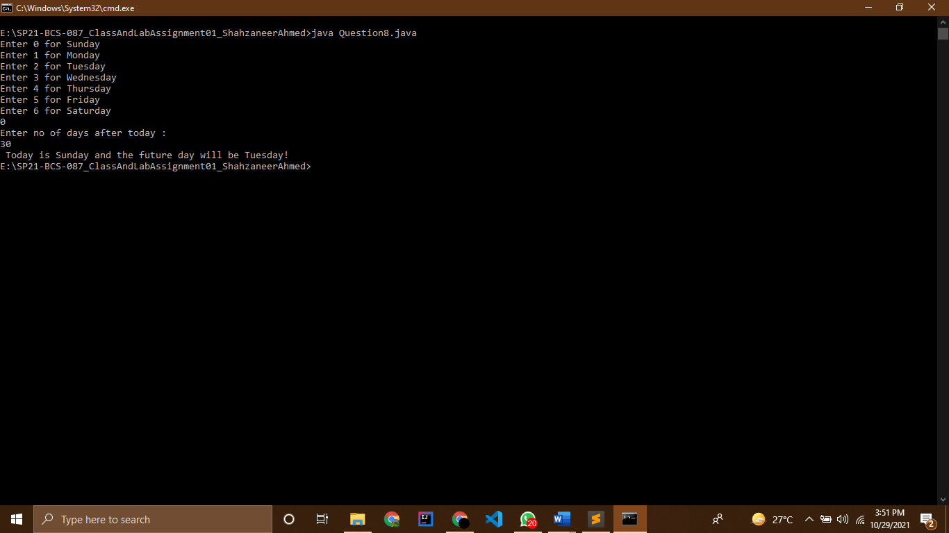

Question 9

Source Code

// |----------------------------------------------------------|

// |------------------Shahzaneer Ahmed------------------------|

// |-------------------SP21-BCS-087---------------------------|

// |----------------------------------------------------------|

//Question-9:

// An ISBN-10 (International Standard Book Number) consists of 10 digits: d1d2d3d4d5d6d7d8d9d10.

// The last digit, d10, is a checksum, which is calculated from the other nine digits using the

// following formula:

// If the checksum is 10, the last digit is denoted as X according to the ISBN-10 convention. Write a

// program that prompts the user to enter the first 9 digits and displays the 10-digit ISBN (including

// leading zeros). Your program should read the input as an integer.

import java.util.Scanner;

public class Question9 {

public static void main(String[] args) {

Scanner obj = new Scanner(System.in);

System.out.println("Enter first 9 digits of ISBN number : ");

System.out.println("Enter 1st digit :");

int d1 = obj.nextInt();

System.out.println("Enter 2nd Digit :");

int d2 = obj.nextInt();

System.out.println("Enter 3rd Digit :");

int d3 = obj.nextInt();

System.out.println("Enter 4th Digit :");

int d4 = obj.nextInt();

System.out.println("Enter 5th Digit :");

int d5 = obj.nextInt();

System.out.println("Enter 6th Digit :");

int d6 = obj.nextInt();

System.out.println("Enter 7th Digit :");

int d7 = obj.nextInt();

System.out.println("Enter 8th Digit :");

int d8 = obj.nextInt();

System.out.println("Enter 9th Digit :");

int d9 = obj.nextInt();

int checkSum = (d1*1 + d2*2 + d3*3 + d4*4 + d5*5 + d6*6 + d7*7 + d8*8 + d9*9) % 11;

if (checkSum == 10) System.out.printf("the number is : %d%d%d%d%d%d%d%d%dX",d1,d2,d3,d4,d5,d6,d7,d8,d9);

else System.out.printf("the number is : %d%d%d%d%d%d%d%d%d1",d1,d2,d3,d4,d5,d6,d7,d8,d9);

}

}

Screenshots

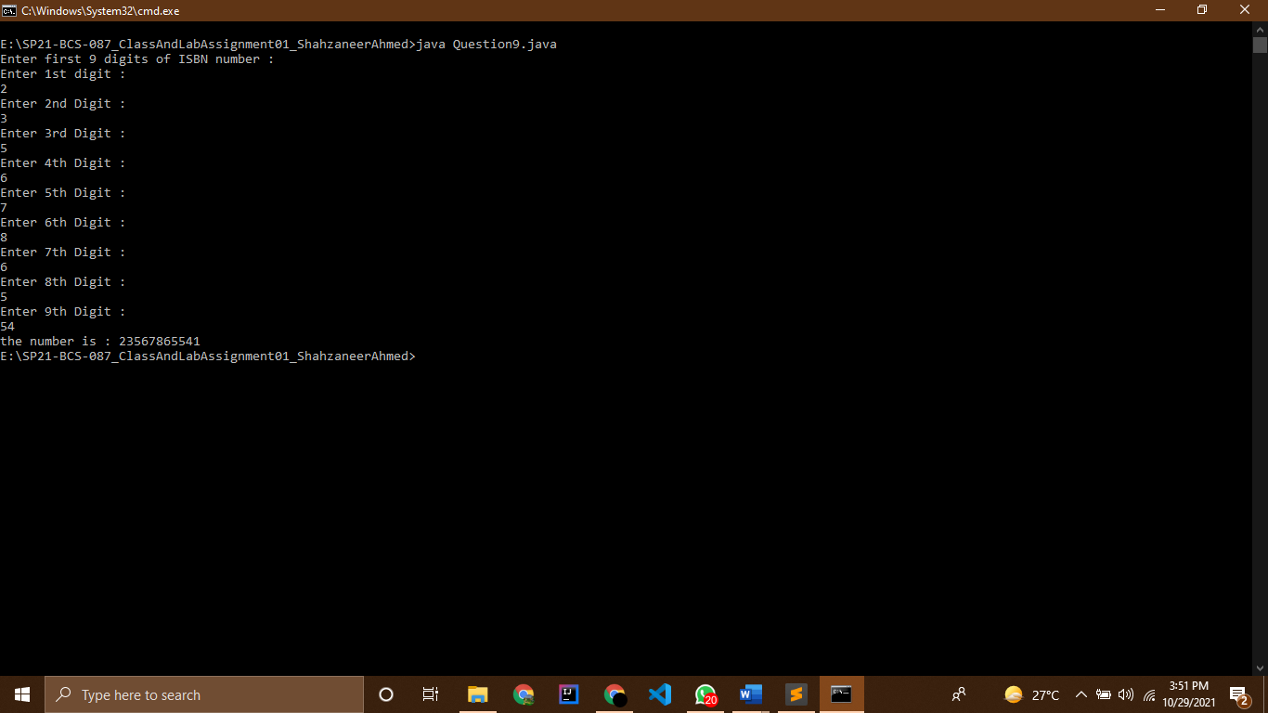

Question 10

Source Code

// |----------------------------------------------------------|

// |------------------Shahzaneer Ahmed------------------------|

// |-------------------SP21-BCS-087---------------------------|

// |----------------------------------------------------------|

//Question – 10:

// Write a program that prompts the user to enter the month and year and displays the number of

// days in the month. For example, if the user entered month 2 and year 2012, the program should

// display that February 2012 had 29 days. If the user entered month 3 and year 2015, the program

// should display that March 2015 had 31 days

import java.util.Scanner;

public class Question10 {

public static void main(String[] args) {

Scanner obj = new Scanner(System.in);

System.out.println("Enter the no of month :");

int month_no = obj.nextInt();

System.out.println("Enter the year :");

int year_no = obj.nextInt();

String month_name = "";

boolean isLeap = false;

// to check whether the year is leap or not !

if (month_no == 2){

if ((year_no%4==0) && (year_no%100!=0)){

isLeap = true;

}

else if ((year_no%4==0) && (year_no%100==0 && (year_no%400==0))){

isLeap = true;

}

}

switch (month_no){

case 1:

month_name = "January";

System.out.printf("The %s %d has 31 days " ,month_name , year_no);

break;

case 2:

month_name = "February";

if (!isLeap){

System.out.printf("The %s %d has 28 days ", month_name, year_no);

break;

}

else if (isLeap){

System.out.printf("The %s %d has 29 days " ,month_name , year_no);

break;

}

case 3:

month_name = "March";

System.out.printf("The %s %d has 31 days " ,month_name , year_no);

break;

case 4:

month_name = "April";

System.out.printf("The %s %d has 30 days " ,month_name , year_no);

break;

case 5:

month_name = "May";

System.out.printf("The %s %d has 31 days " ,month_name , year_no);

break;

case 6:

month_name = "June";

System.out.printf("The %s %d has 30 days " ,month_name , year_no);

break;

case 7:

month_name = "July";

System.out.printf("The %s %d has 31 days " ,month_name , year_no);

break;

case 8:

month_name = "August";

System.out.printf("The %s %d has 31 days " ,month_name , year_no);

break;

case 9:

month_name = "September";

System.out.printf("The %s %d has 31 days " ,month_name , year_no);

break;

case 10:

month_name = "October";

System.out.printf("The %s %d has 31 days " ,month_name , year_no);

break;

case 11:

month_name = "November";

System.out.printf("The %s %d has 30 days " ,month_name , year_no);

break;

case 12:

month_name = "December";

System.out.printf("The %s %d has 31 days " ,month_name , year_no);

break;

}

}

}

Screenshots

